**Avoiding Online Dangers**

**What is the danger shown by this image?**

**Cyberbullying Hurts people**

**List as many ways as you can think to avoid this danger**:

Put your accounts on private

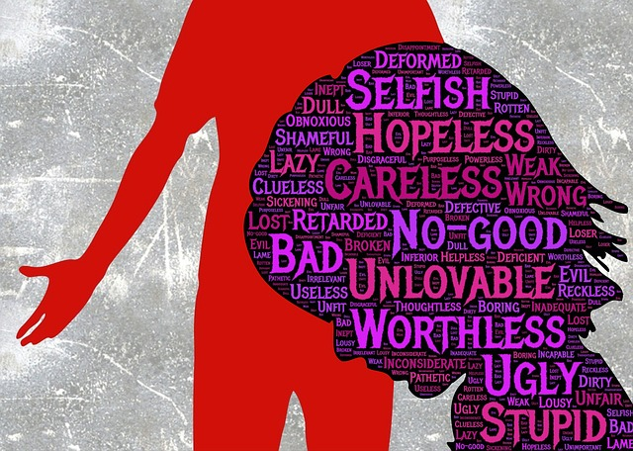

**What is the danger shown by this image?**

**Credits Card fraud**

**List as many ways as you can think to avoid this danger**:

People can access your account and steal your money



**What is the danger shown by this image?**

Virus

**List as many ways as you can think to avoid this danger**:

Delete system32 and will break your pc



**What is the danger shown by this image?**

**List as many ways as you can think to avoid this danger**:

**What is the danger shown by this image?**

**List as many ways as you can think to avoid this danger**:

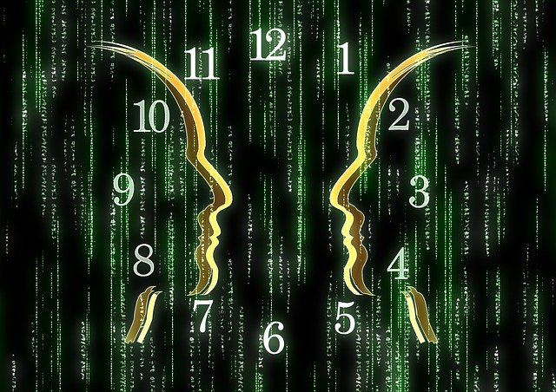

**What is the danger shown by this image?**

**List as many ways as you can think to avoid this danger**: